London HIV Ambassadors Programme
3-year evaluation
Summary report

Jen Illman
Lived Experiences Programme Manager
Terrence Higgins Trust

July 2026

The London HIV Ambassadors Programme was a three-year lived experience-led initiative funded by Fast-Track Cities London and delivered by Terrence Higgins Trust. It was developed to reduce HIV stigma by recruiting, training and supporting people living with HIV to share their experiences with professional, public sector and community audiences across London. It ran from April 2023 to March 2026, when its legacy was ensured by a merger with the Terrence Higgins Trust Positive Voices Programme, delivering lived experience training and HIV stigma interventions across the UK. This summary report is accompanied by a comprehensive evaluation report that sets out the programme's delivery, outcomes, and evaluation findings in detail, together with recommendations for providers and commissioners seeking to develop and deliver similar initiatives.
25  Ambassadors recruited | 117  Talks delivered | 6,175  People reached directly through talks
66  Social media posts | 161,282  Social & digital reach | 167,523  Total reach
Why it mattered
The programme showed that lived experience can make HIV personal, human and relevant. Audiences reported stronger HIV knowledge, greater confidence and reduced misconceptions. Ambassadors reported increased confidence, connection, self-acceptance and advocacy skills.
“Completely changed my outlook on my status, I feel proud that I can share my story and hopefully help others, something that didn’t seem possible before.”
London HIV Ambassador

Reach: a city-wide programme with wider public influence
Across three years, Ambassadors delivered training and public engagement across health and care, education, policing, local authority, voluntary sector, professional and public audiences. The strongest direct delivery footprint was in NHS, student and police settings, with wider influence through campaigns, media, podcasts, blogs and events.
163
Hours of talks delivered
209
Speaker slots
1.77
Average speakers per talk
3,500
Estimated additional reach through blogs and podcasts

Public engagement amplified the work
Ambassador-led media, blogs, podcasts and social media brought lived experience into wider public conversations about HIV, stigma, testing, PrEP, Can’t Pass It On/U=U, Pride, ageing, dating, disclosure and community attitudes. Ambassadors received media training and ongoing support to build their confidence and skills as spokespeople and were connected to media opportunities through our media team and strong relationships with journalists. As a result, Ambassadors shared their stories through a range of regional and national outlets, including BBC Politics London, BBC News, BBC South East, ITV Meridian News, The Mirror, Gay Star News and Radio Next, helping to ensure authentic lived experience voices reached diverse audiences and contributed to greater public understanding of HIV and the realities of living with the condition.
Talks and training  117 recorded talks across London, including NHS, students, policing, local authority, voluntary sector and professional bodies. |  | Campaigns and media  Ambassadors appeared in media, podcasts, blogs, public campaigns and events, extending reach beyond training rooms. |  | System influence  The programme contributed to GP engagement, HIV Confident development, public health activity and the future Positive Voices model.

Impact: knowledge, confidence and stigma reduction
The evaluation drew on 782 pre-session surveys and 382 post-session surveys across health and care and police audiences, alongside qualitative participant feedback and input from Ambassadors through surveys and co-production sessions.

Health and care  Confidence in offering an HIV test also improved from 43 to 66., and participants strongly agreed the session helped them gain a deeper understanding of HIV stigma and practices they might change, with a mean score of 90.2, |  | Police audiences  Agreement that it’s acceptable for someone living with HIV to serve as a police officer increased from 69.2% to 90.2%, and 97.7% felt more confident dealing with people living with HIV after the session. |  | Lived experience  Participants repeatedly described Ambassador stories as powerful, memorable and practice-changing, and that lived experience helped them connect factual learning with empathy, reflection and intended changes in care and behaviour.

“Amazing, reshaped my understanding of HIV and is making me question previous practice I’ve seen. This will positively affect my treatment of patients! Thank you.”
Health and care participant

100%
Ambassadors clear about role expectations
78%
Ambassadors felt appreciated for their work
78%
Ambassadors had the right tools for their role

Ambassador feedback shows the model also increased confidence, self-acceptance and skills, whilst providing community and supporting advocacy

Legacy: from London HIV Ambassadors to Positive Voices
The programme created reciprocal impact: audiences gained knowledge, confidence and empathy, while Ambassadors gained confidence, visibility, community and advocacy opportunities. This legacy now continues through Positive Voices, Terrence Higgins Trust’s lived experience speaker programme.
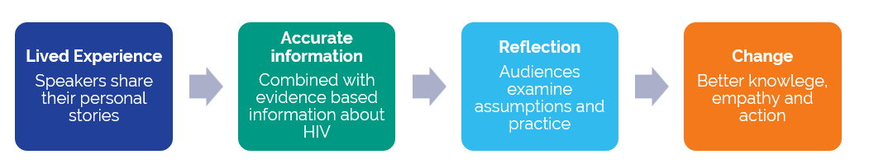
How Positive Voices continues the model: trained speakers + up to date HIV knowledge + practical learning for audiences
In 2026 we presented a poster at the joint BHIVA/BASHH conference highlighting the impact of our HIV stigma work in the health and care sector, delivered by trained speakers living with HIV through Positive Voices and the Ambassador programme, and supported by digital learning resources.
Since 2021 outcomes from 8,813 health and care staff and students who attended 165 live training sessions, demonstrated substantial improvements in HIV knowledge and confidence. Self-reported confidence in having discussions with patients or colleagues living with HIV increased from 51.5 to 78.6 out of 100, with participants consistently identifying the contribution of lived experience speakers as the most impactful element of the training.
These findings help demonstrate the scalability and effectiveness of the model that now continues through Positive Voices.

Positive Voices continues this work  Book a session, partner with us, or work with speakers to bring an authentic, engaging and impactful perspective on HIV, stigma and inclusion to your audiences.  speakers@tht.org.uk  tht.org.uk/speakers | What we offer  - Powerful stories that open discussions about inclusion, wellbeing and belonging  - Evidence-based training on HIV  - Practical suggestions for tackling HIV stigma in your setting  - Twenty years’ experience delivering to over 70,000 people in workplaces, health and care, schools, universities, community organisations and the public sector.  - A proven model built on speaker support, co-production and practical learning  - The opportunity to support an organisation directly working with people living with HIV

“As a collective we have shown that people living with HIV are incredible, and that our stories are filled with richness, integrity, depth and the ability to influence.”
London HIV Ambassador

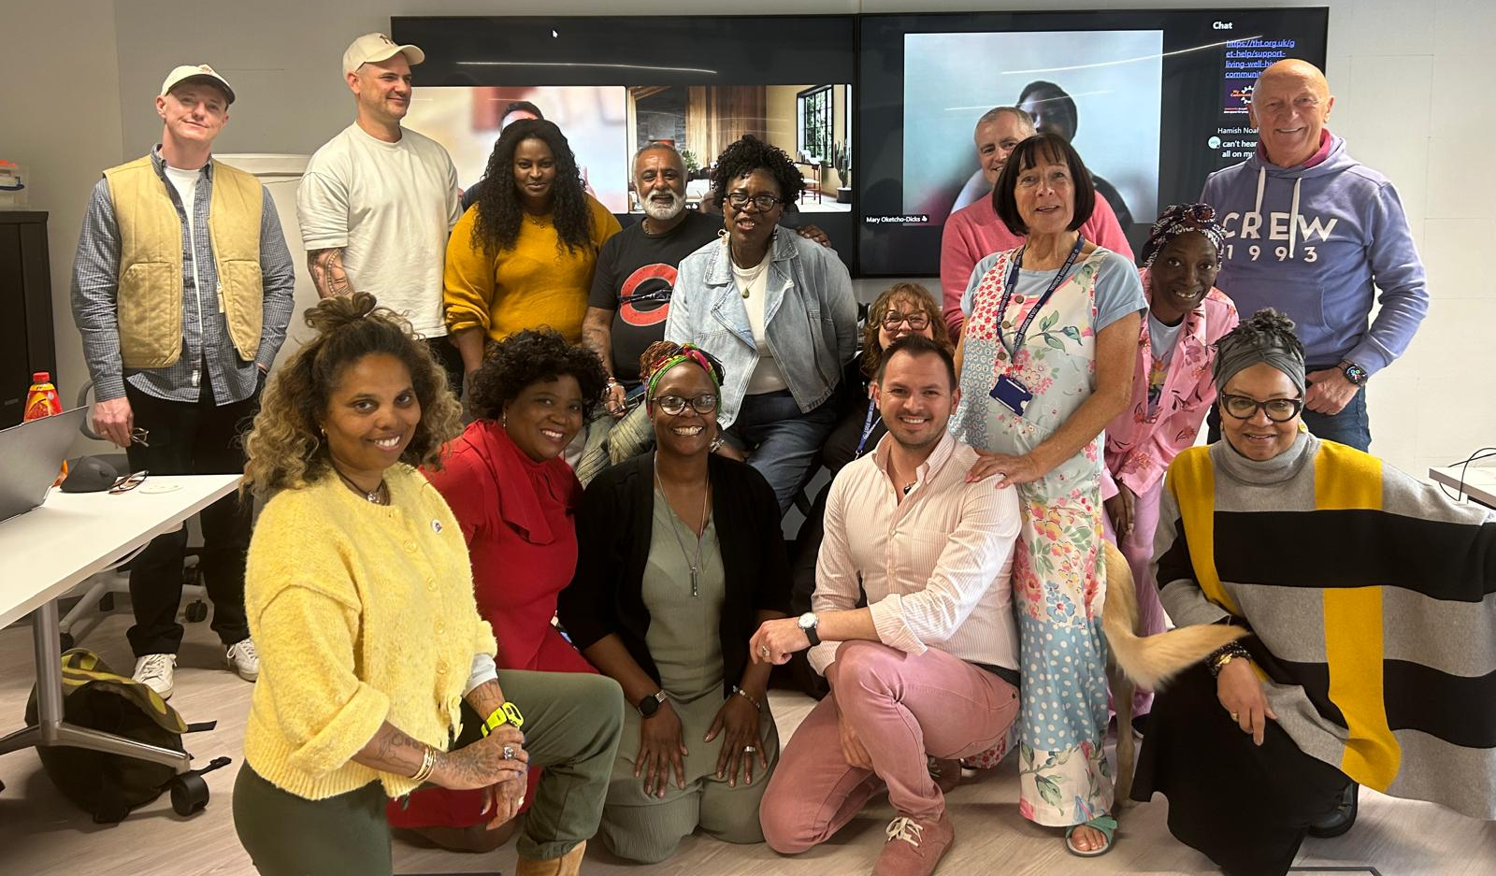

Figures do not include reach for media appearances or social media reach where posts where shared by other users as these cannot be quantified. They also do not include talks delivered by Ambassadors for other programmes, such as Positive Voices. Total reach will therefore likely be much higher than quoted.

